Circuit Analysis (Lab10)
Experiment 9: Verification of Thevenin’s Theorem

Name: Sagheer Hussain Registration No: CE-2025-109
Date: 11-May-2026 Grade and Signature: ……………………
CLO2 CLO3 | Use with identification the circuit components, breadboards, multimeter, power supplies, signal generators, and oscilloscopes. Make measurements in their own constructed electric circuits.
Psychomotor/Affective | Level1  (1) | Level2 (2-3) | Level3 (4-5) | Level4 (6-7)
Report Marks (3)
 | Total marks (10)

Objective
The objective of this lab is verify Thevenin’s theorem and to find the full load current.

Apparatus Required
Sr. no | Apparatus | Range | Quantity
1 | Regulated Power Supply | Standard | 1
2 | Signal Generator | Standard | 1
3 | Oscilloscope | Standard | 1
4 | Digital Multimeter | Standard | 1
5 | Breadboard & Wires | Standard | As Required
6 | Resistors | 1k, 330 ohms | 1,3
7 | Potentiometer | Standard | 1
Description

Statement:
Any linear bilateral, active two terminal network can be replaced by an equivalent voltage source (VTH). Thevenin’s voltage or V OC in series with looking pack resistance RTH.

Precautions:
- Voltage control knob of RPS should be kept at minimum position.
- Current control knob of RPS should be kept at maximum position

Procedure:
- Connections are given as per the circuit diagram.
- Set a particular value of voltage using RPS and note down the corresponding ammeter readings. To find VTH 3. Remove the load resistance and measure the open circuit voltage using multimeter (VTH). To find RTH
- To find the Thevenin’s resistance, remove the RPS and short circuit it and find the RTH using multimeter.
- Give the connections for equivalent circuit and set VTH and RTH and note the corresponding ammeter reading. 6. Verify Thevenins theorem.
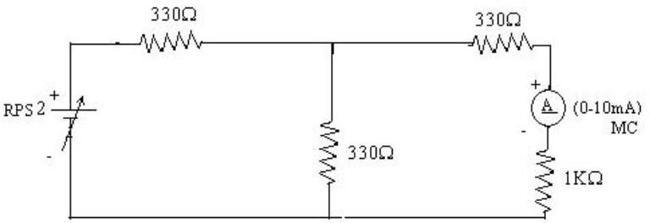
Circuit - 1: To find load current

To find VTH
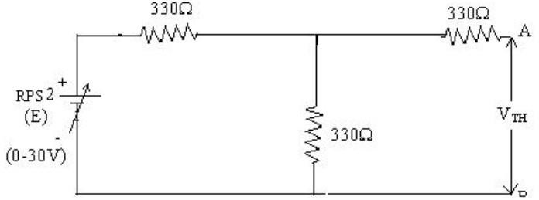

To find RTH
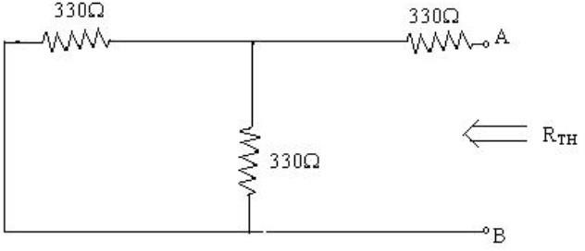

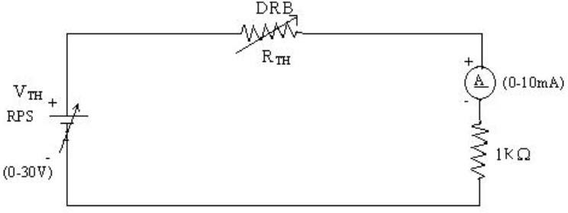
Thevenin’s Equivalent circuit:

Thevenin Practical Values

 | E(V) | VTH(V) | RTH(ohms) | IL (mA)
 |  |  |  | Circuit - I | Equivalent Circuit
Values | 15 | 7.5 | 495 | 5.02 | 5.02

Post Lab Questions

1. What is Thevenin’s Theorem?
Thevenin’s Theorem states that any linear electrical circuit can be replaced by an equivalent circuit containing one voltage source and one series resistance.
The equivalent voltage is called Thevenin voltage (Vth), and the equivalent resistance is called Thevenin resistance (Rth).
This theorem helps simplify complicated circuits for easier analysis.
It is mainly used to determine current and voltage across a load resistor.
The theorem applies only to linear and bilateral networks.

2. What are the applications of Thevenin’s Theorem?
Thevenin’s Theorem is used to simplify complex electrical circuits into simple equivalent circuits.
It helps engineers calculate load current and voltage easily.
The theorem is widely used in circuit analysis and troubleshooting.
It is useful when studying the effect of different load resistors.
Thevenin’s theorem is also applied in power systems, electronics, and communication circuits.

3. What are the theoretical and practical limitations of Thevenin’s Theorem?
Thevenin’s Theorem is applicable only to linear and bilateral circuits.
It cannot be directly used for non-linear devices like diodes and transistors.
The theorem becomes difficult to apply in large and complicated networks.
Dependent sources require extra calculations during analysis.
In practical circuits, measurement errors and changing circuit conditions can reduce accuracy.

